Lab-5 Basic RIP Configuration and Analysis
Step 5: Examine and verify RIPv1 configurations.
Answer the following questions:
Q5-1.1. Paste the screenshot of the created topology.
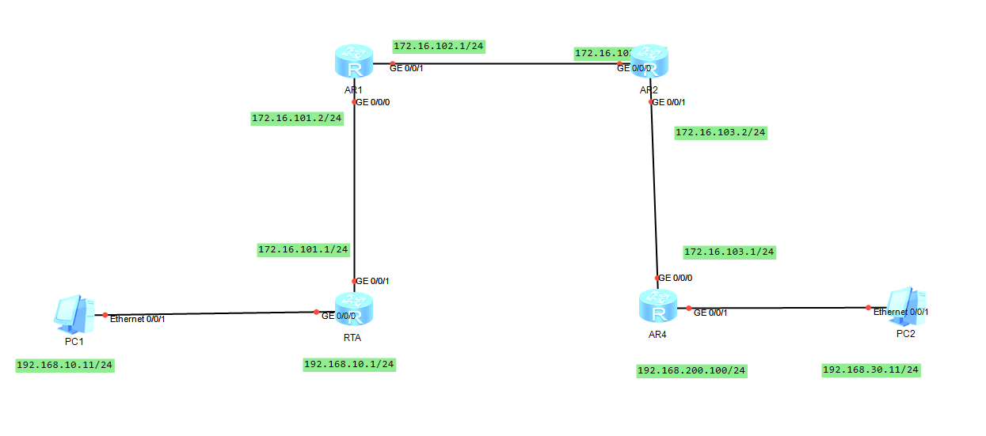
Q5-1.2. Paste the screenshot of the IP routing table on the router RTA. Highlight the RIPv1 routes in the screenshot. Which routes are learned from the RIP neighbors?
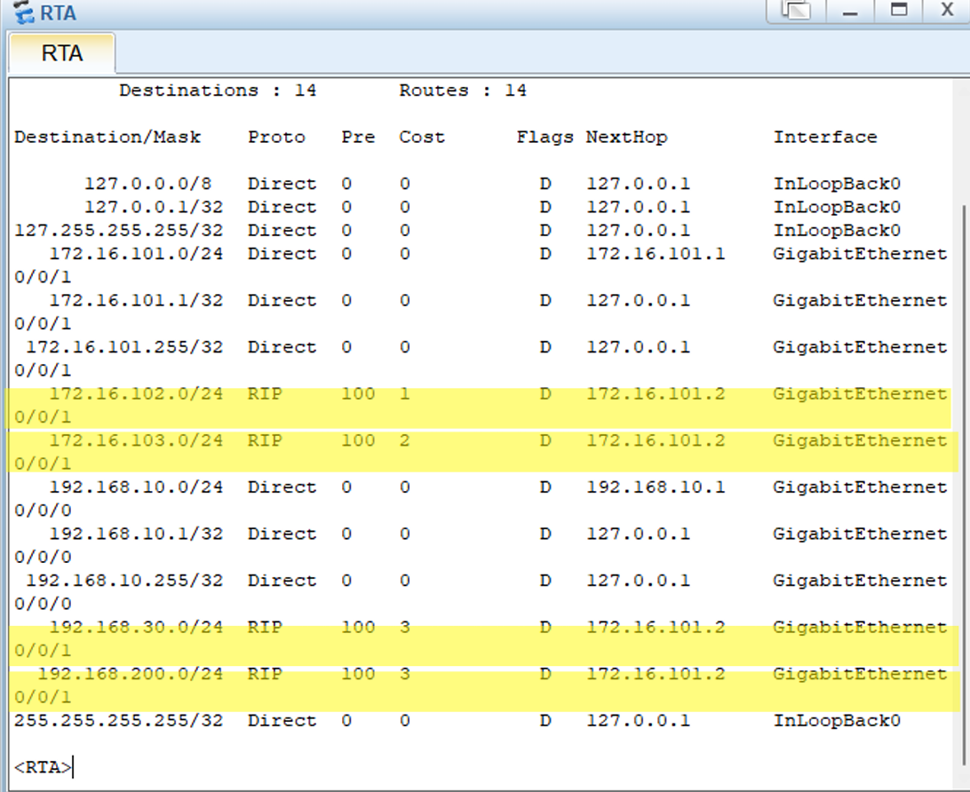
Q5-1.3. Paste the screenshot of the IP routing table on the router RTB. Highlight the RIPv1 routes in the screenshot. Which routes are learned from the RIP neighbors?
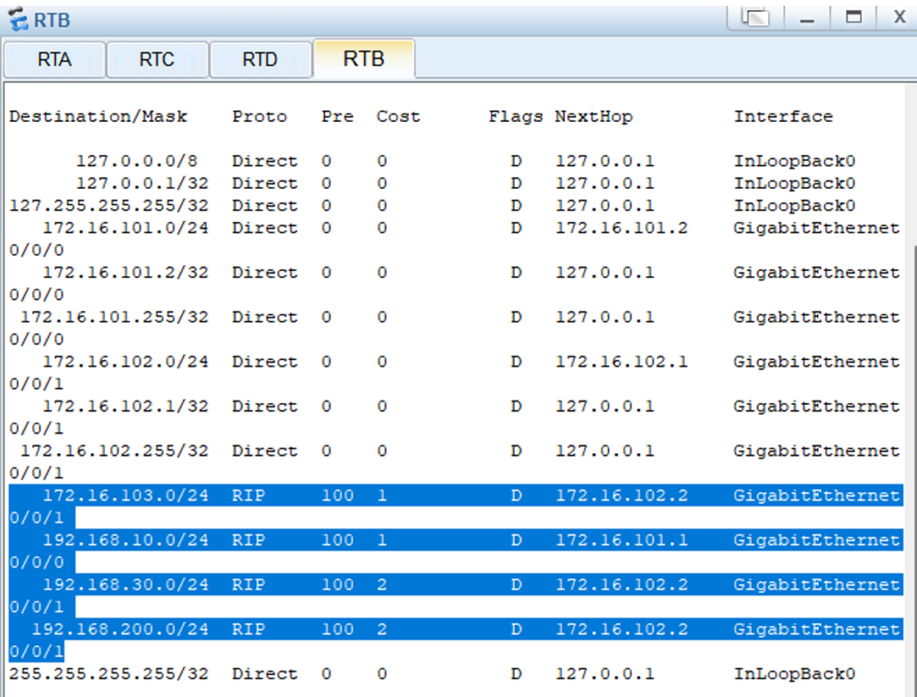

Q5-1.4. Paste the screenshot of the IP routing table on the router RTC. Highlight the RIPv1 routes in the screenshot. Which routes are learned from the RIP neighbors?
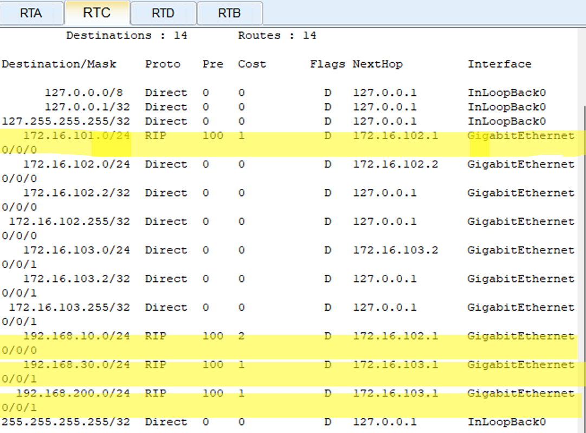
Q5-1.5. Paste the screenshot of the IP routing table on the router RTD. Highlight the RIPv1 routes in the screenshot. Which routes are learned from the RIP neighbors?
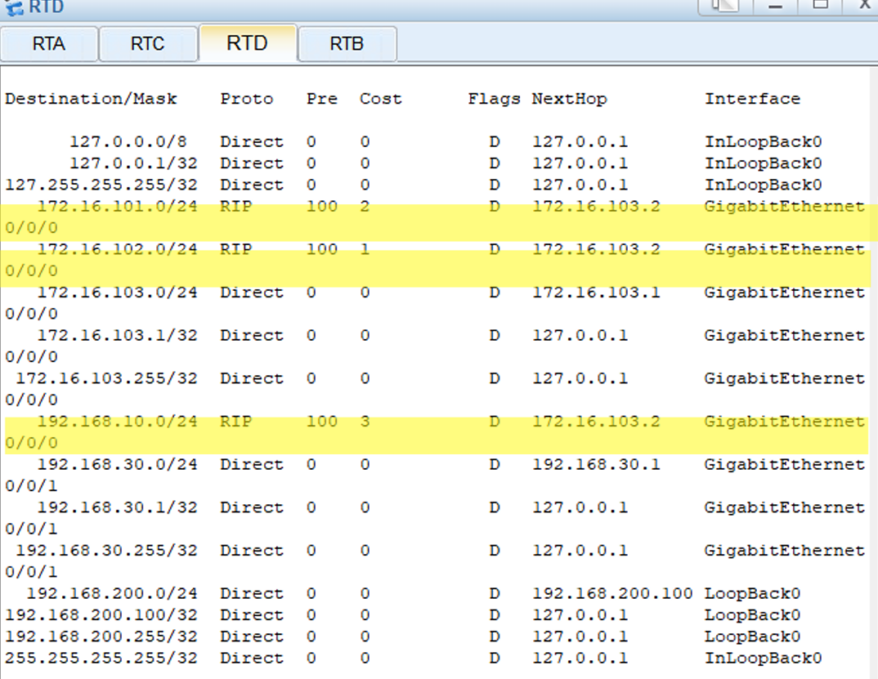
Q5-1.6. Can PC-10-1 and PC-30-1 ping each other? Please paste the screenshot of the ping result.
YES, they can. 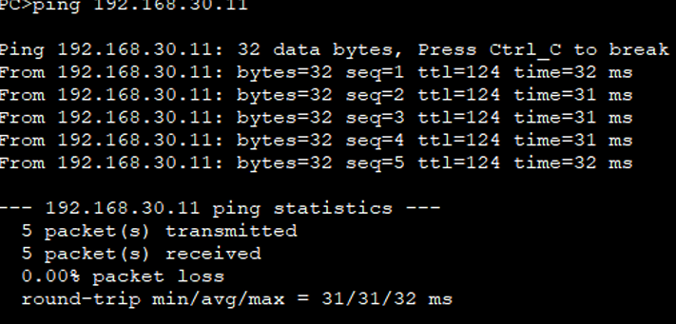

Q5-1.7. Can PC-10-1 and loopback 0 on RTD ping each other? Please paste the screenshot of the ping result.
YES, they can. 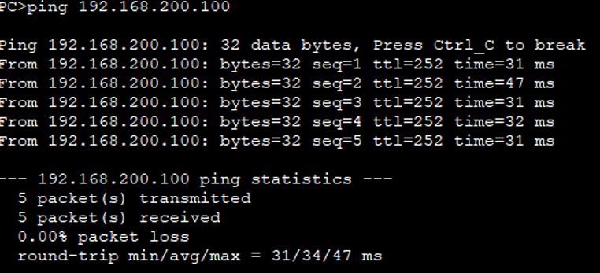
Q5-1.8. Please paste the screenshot of the result of command “tracert 192.168.30.11” issued from PC-10-1.
YES, they can. 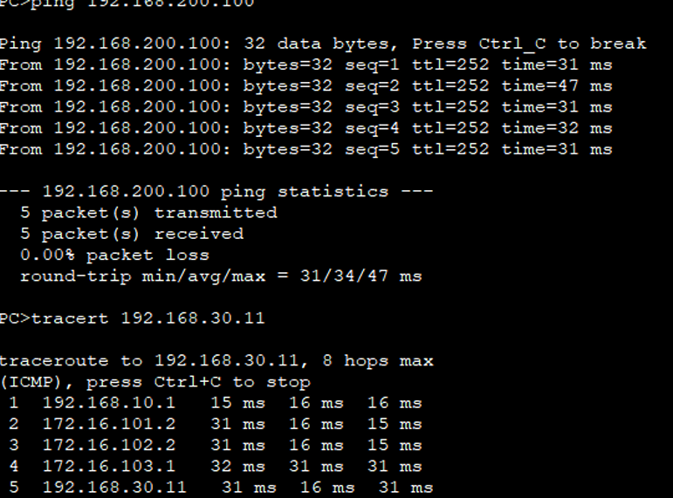

Step 6: Analyze RIPv1 traffic.
Answer the following questions:
Q5-1.9. How many types of RIPv1 packets are there? What are they?
Two types are identified:
(1) Request
(2) Response
Q5-1.10. What is the interval between RIPv1 routing updates?
30s
Q5-1.11. Which protocol does RIPv1 use to transmit RIP packets? What are the source port number and destination port number?
The protocol operates over the transport layer using UDP, with both the source and destination port numbers set to 520.
Q5-1.12. When RIPv1 sends a routing update message, what is the destination IP address of the message? What type of IP address is it?
The protocol uses the multicast address 224.0.0.9 for message dissemination.
Q5-1.13. How many routes are there in each RIPv1 route update message? What information does each route contain in the route update message? Please paste the screenshot of the route information contained in the captured update routing message.
The routing table contains three entries, and each entry includes an address family identifier, a destination IP address, and the associated routing metric (cost).
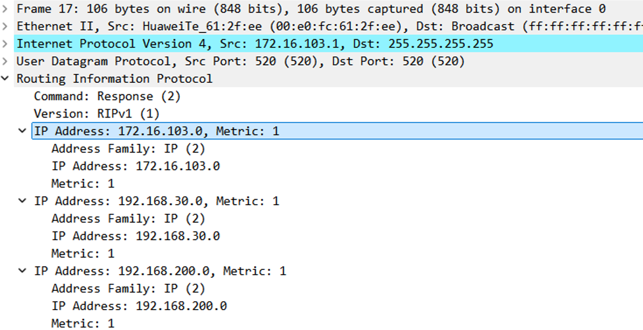
Q5-1.14. Please give the format of RIPv1 routing update message.
Each RIPv1 message is encapsulated in a UDP packet using port 520 and follows this structure:
Header (4 bytes total)
- Command (1 byte): Indicates the type of message.
  - Value 1: Request
  - Value 2: Response
- Version (1 byte): RIP version number. For RIPv1, this is 1.
- Zero (2 bytes): Unused; must be set to zero.
Routing Entries (up to 25 entries, each 20 bytes)
Each routing entry includes the following fields:
- Address Family Identifier (2 bytes)
  - For IP, this is 2.
- Route Tag (2 bytes)
  - Not used in RIPv1; must be zero.
- IP Address (4 bytes)
  - Destination network address.
- Subnet Mask (4 bytes)
  - Not used in RIPv1; must be zero.
- Next Hop (4 bytes)
  - Not used in RIPv1; must be zero.
- Metric (4 bytes)
  - Represents the hop count to the destination. Range: 1 (directly connected) to 16 (infinite, unreachable).

